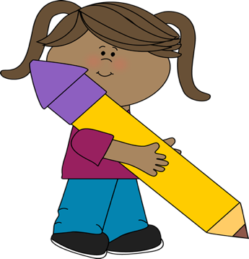
This Photo by Unknown Author is licensed under CC BY-SA-NC
Editing checklist

1. I used my best handwriting.

2. I left spaces between words.

3. I capitalized the first letter of each sentence and
names of people and places.

4. I used the correct punctuation for each sentence.

5. I used my best spelling.

6. I introduced the topic and ended with a
conclusion.

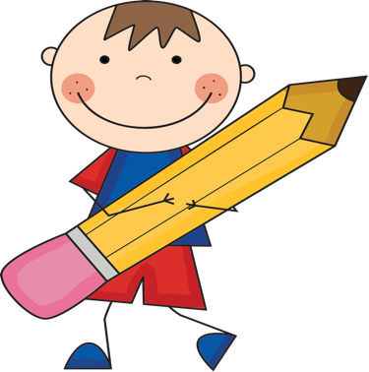
This Photo by Unknown Author is licensed under CC BY-SA-NC

