**Do some basic fast facts practice.**

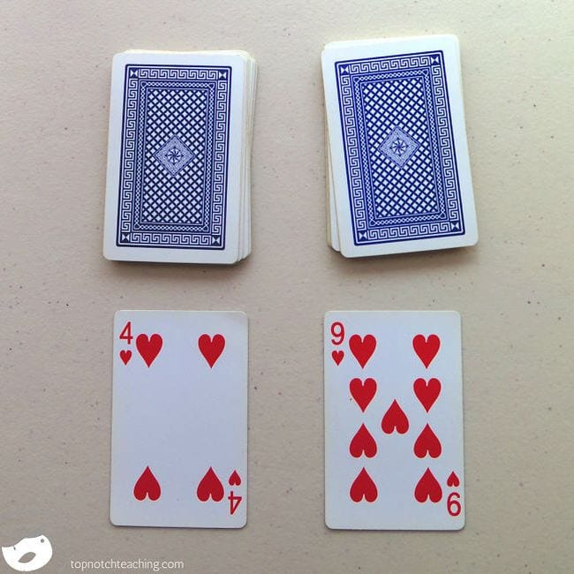

Give your flash cards a rest and practice facts with math card games instead. Simply lay down two cards from the deck (remove the face cards first) and add, subtract, or multiply them. Kids can work on this alone, or you can make it a contest to see who can call out the correct answer first.