La course des formes!

Take a walk in your neighborhood.
Each time you see a shape, draw a short line in the right row (see the table below). Draw a horizonal line when you reach 5 and keep on going.

Ex. //// //// //

Find out which shape is most used around you! This shape is the winner! Practice saying the name of all shapes in French.

Un cercle | Total: _____
Un triangle | Total: _____
Un rectangle | Total: _____
Un pentagone | Total: _____
Un hexagone | Total: _____
Un octogone | Total: _____

Mon recyclage à la loupe

Raven recycling has been closed for a little while. Let’s see which 3D shapes you can find in your recycling bins! Find one or more everyday life objects that have these shapes and draw them in the table below.

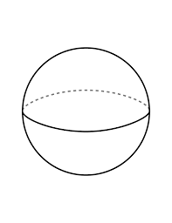
Une sphère

Une pyramide à base triangulaire
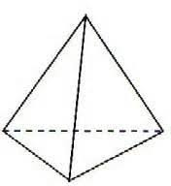

Une pyramide à base carré
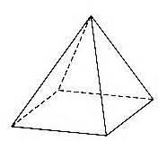

Un
prisme rectangulaire
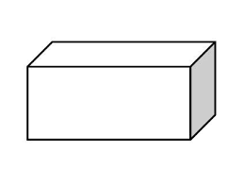
Un
prisme triangulaire
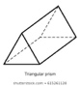
Un cône
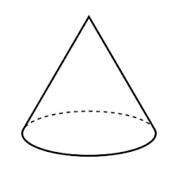
Un cylindre
