May 4th, 2020

Dear EWES families,

My name is Madame Kim Arkesteyn-Vogler and I am the Teacher-Librarian at EWES. I have had the pleasure of meeting all your children and helping them find the perfect books during their weekly library periods.

As we move through these extraordinary times, I will be providing periodic art activities to do at home between now and June 12th. These will come to you through your child’s teacher , either in an email or posted on their website, and are meant to supplement what the classroom teachers are providing as curriculum. These are fun projects you can do as a family and are in no way mandatory. If you have any questions or need support, please don’t hesitate to contact me. I will be answering emails between 10am and noon, Monday to Friday.

Have fun!

Sincerely,

Madame Kim Arkesteyn-Vogler

Teacher-Librarian

Ecole Whitehorse Elementary

[Kim.arkesteyn@yesnet.yk.ca](mailto:Kim.arkesteyn@yesnet.yk.ca)

**MOTHER’S DAY CARD AND NECKLACE**

Mother’s Day is coming up on Sunday, May 10th and I thought it would be nice to make a little something for someone special.

**The card:**

You will need:

* Paper
* Pencil
* Markers, crayons, pencil crayons or paint
* Your hand

What to do:

1. Fold a blank piece of paper in half to make a card
2. Trace your hand onto the cover of the card (as shown)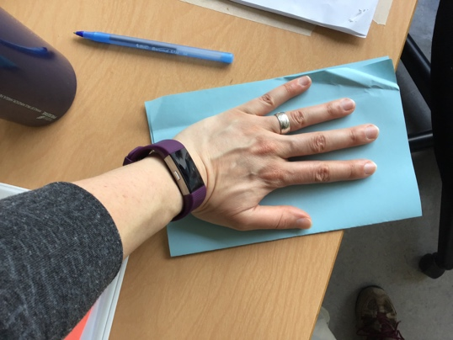
3. Turn your hand into an octopus/jellyfish (as shown)

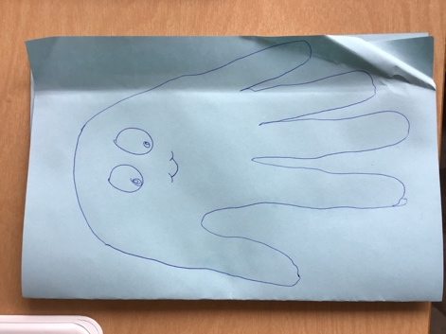

1. Add some colour and details to your octopus
2. Above it write “Happy Mother’s Day” (you can also add your mom’s name. Or grand-mother, aunt, friend…)
3. On the inside of the card, add a personal message and sign your name. Here are some message ideas:
   1. Thank you for all that you do
   2. I love you
   3. You are wonderful
   4. You are the best
   5. I’m lucky to have you in my life
   6. You make me smile
   7. You are a great listener/helper/friend

**The paper-bead necklace:**

You will need:

* Coloured paper (or white paper with designs on it, or old wrapping paper or old magazines/newspapers)
* Scissors
* Tape
* String
* A pencil

What to do:

1. Cut long strips out of the chosen paper
2. Wrap 1 strip at a time around a pencil (as shown). 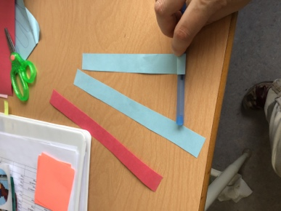
3. Tape the strip to itself to make a bead (as shown)

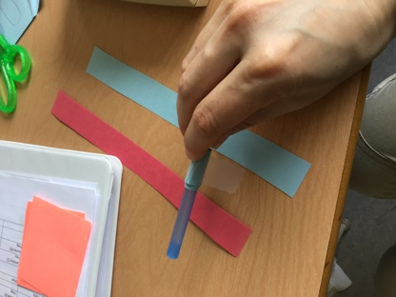

1. Carefully remove the bead from the pencil
2. Repeat steps 1-4 as many times as you like to make beads for the necklace or bracelet.
3. Pull the string through the middle of the beads to make a necklace or bracelet (as shown)

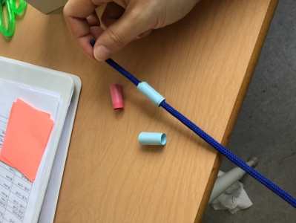

I hope you all have a great week and a wonderful Mother’s Day!

Madame Kim Arkesteyn-Vogler