**Find a way to make 10 (or 15, or 20 … )**

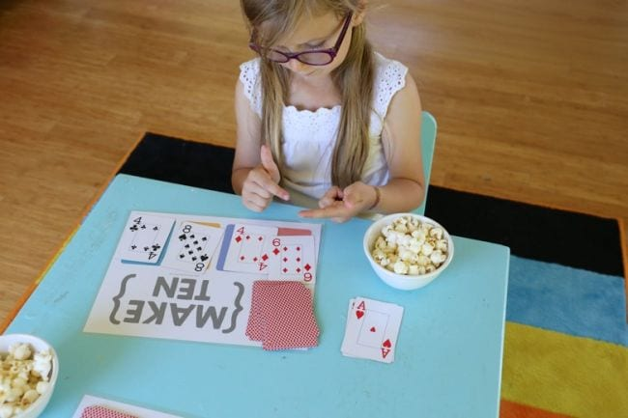

One of the terrific things about math card games is that many of them can be customized for various concepts and skill levels. The original goal of this game was to look at the cards you’re dealt to find ones that add up to 10, but it can be changed to 15, 20, or any number you choose. You can also add to the difficulty by allowing addition and subtraction (for example, you could use 8+4=12 or 12-2=10). Get the rules and free printable mats at the link below.