You will find below links to optional Earth Day crafts.

Seed bombs

<https://littlebinsforlittlehands.com/make-seed-bombs-earth-day-activity/>

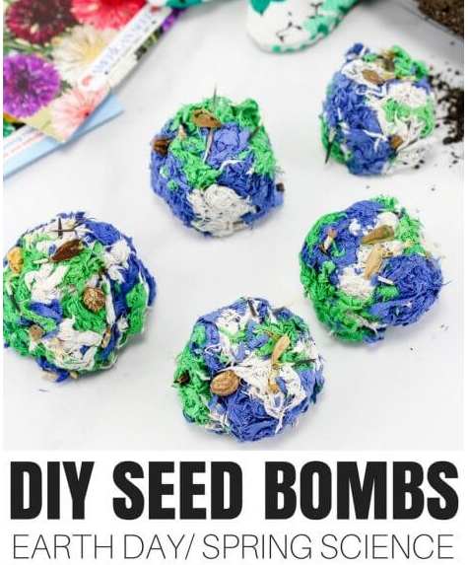

Coffee Filter Butterflies

<https://www.organizedisland.com/how-to-make-coffee-filter-butterflies/>

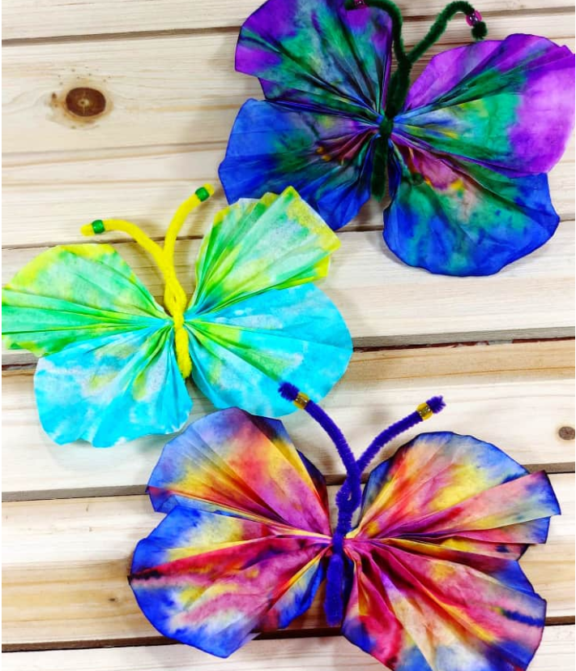

Cookies

<https://www.tammileetips.com/earth-day-cookies/>

